Indonesian Foreign Minister: Australia-ASEAN Anchoring Regional Stability

Jakarta, 13 July 2023. Indonesia hopes that Australia can become a key partner for ASEAN in maintaining peace and stability in the Indo-Pacific region. This statement was made by Foreign Minister Retno Marsudi during the ASEAN Post Ministerial Conference (PMC) with Australia on Wednesday (13/7) in Jakarta.

Minister Retno stated that Australia can be a positive force in the region by supporting ASEAN's centrality. She emphasized Australia's status as one of the four ASEAN partners with a Comprehensive Strategic Partnership.

"We have high expectations for Australia to become a positive force in the region and support ASEAN's centrality in shaping regional dynamics," explained Minister Retno.

Minister Retno highlighted two areas of cooperation that can be focused on.

The first one involves regional peace and stability. Minister Retno expressed that Australia and ASEAN can play a role as anchors of stability in the Indo-Pacific.

"We need to build an inclusive regional architecture where all parties feel secure and contribute to the prosperity of the region. Australia can become a true partner of ASEAN and anchor peace and stability in the Indo-Pacific," emphasized Minister Retno.

Secondly, Australia is expected to become a development partner in the Pacific region. In this regard, Minister Retno conveyed that the Pacific region is an integral part of the Indo-Pacific. Therefore, concrete cooperation is needed between ASEAN and Pacific countries, including in areas such as climate action and disaster risk reduction, food security, and blue economy.

Minister Retno also hoped for Australia's support for cooperation between the ASEAN Secretariat and the Pacific Islands Forum (PIF) to commence this year.

At this meeting, ASEAN foreign ministers expected to increased concrete cooperation with Australia in several areas, including trade, connectivity, health, education, transportation, climate change, and sustainable energy. They also hoped that Australia could become an anchor for economic growth in the southern part of the Indo-Pacific. Additionally, ASEAN countries also expected Australia to support regional stability and peace, including by supporting ASEAN's common position on the South China Sea.

Meanwhile, Australian Foreign Minister Penny Wong affirmed support for ASEAN's centrality in maintaining stability and achieving regional prosperity through the concrete implementation of the ASEAN Outlook on the Indo-Pacific (AOIP). Furthermore, Australia has formulated the 2040 Southeast Asia Strategy to enhance economic cooperation with ASEAN.

The meeting agreed upon the Concept Note for the ASEAN-Australia Commemorative Summit. The ASEAN-Australia Commemorative Summit will be held next year.

***

For further information, please contact the following:

Director for Information and Media of the Ministry of Foreign Affairs - Hartyo Harkomoyo (+62811831899)

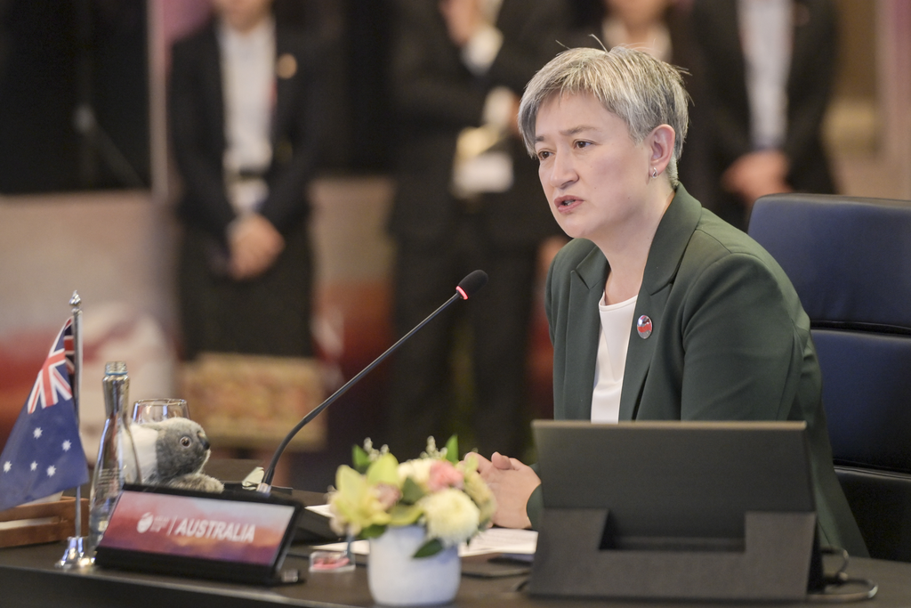

Indonesia hopes that Australia can become a key partner for ASEAN in maintaining peace and stability in the Indo-Pacific region during the ASEAN Post Ministerial Conference (PMC) with Australia in Jakarta (13/7) (Photo: Ministry of Foreign Affairs of Indonesia).

